**Department of Electrical Engineering and   
Computer Science**

**Faculty Member:** Dr. Huma Ghafoor  **Dated:** 16/03/2023

**Semester:** 6th **Section:** BEE 12C

**EE-351 Communication Systems**

Lab 7: SSB Transmission

Group Members

|  |  |  |  |  |  |  |
| --- | --- | --- | --- | --- | --- | --- |
| **Name** | **Reg. No** | **Viva / Quiz / Lab Performance** | **Teamwork** | **Ethics** | **Software Tool Usage** | **Analysis of data in Lab Report** |
|  |  | **5 Marks** | **5 Marks** | **5 Marks** | **5 Marks** | **5 Marks** |
| Muhammad Ali Farooq | 331878 |  |  |  |  |  |
| Danial Ahmad | 331388 |  |  |  |  |  |
| Muhammad Umer | 345834 |  |  |  |  |  |
| Tariq Umar | 334943 |  |  |  |  |  |

**Table of Contents**

2 SSB Transmission 3

2.1 Objectives 3

2.2 Introduction 3

2.3 Lab Report Instructions 3

3 Exercise 1 4

3.1 Introduction 4

3.2 Procedure A: Balanced Modulator 4

3.3 Procedure B: LSB Filter 6

3.4 Deliverables 8

4 Exercise 2: Mixer and RF Amplifier 12

4.1 Introduction 12

4.2 Procedure A: Adjust the Circuit for a 455 kHz to the MIXER 13

4.3 Procedure B: Convert the 455 kHz SSB to a 1000 kHz SSB 14

4.4 Procedure C: RF Power Amplifier and Antenna Matching Network 15

4.5 Deliverables 16

5 Conclusion 18

# SSB Transmission

## Objectives

* You will be able to describe that how a balanced modulator is used to generate DSB signal, explain how the SSB is output from LSB filter. And explain how an SSB have low power consumption and narrow bandwidth.

## Introduction

Balanced modulators are used to generate DSB signals by multiplying a carrier signal with the modulating signal. The modulating signal can either be an analog or digital signal. The balanced modulator produces two sidebands, upper and lower, which are symmetrically placed around the carrier frequency. To extract SSB signals from the DSB signal, a filtering process is required. The LSB filter can be used to remove the unwanted sideband, leaving only the desired SSB signal.

SSB signals have several advantages over DSB signals. They have lower power consumption and require less bandwidth, making them ideal for long-distance communication. Moreover, SSB signals can be easily demodulated using simple envelope detection circuits.

## Lab Report Instructions

All questions should be answered precisely to get maximum credit. Lab report must ensure following items:

* Lab objective
* Results (screen shots) duly commented and discussed.
* Conclusion

# Exercise 1

## Introduction

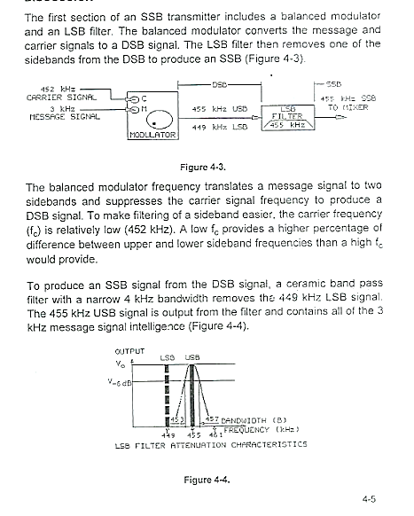

## Procedure A: Balanced Modulator

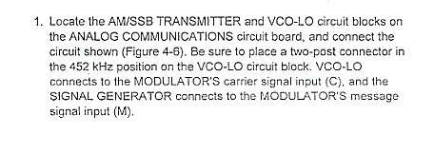

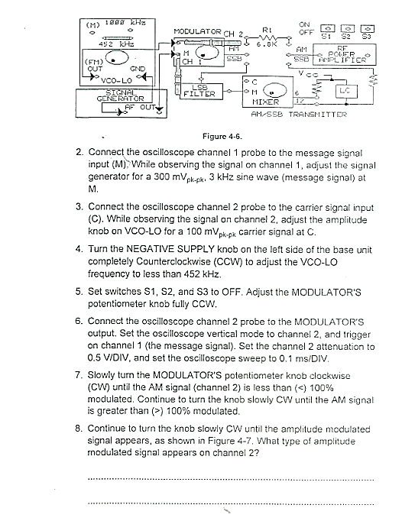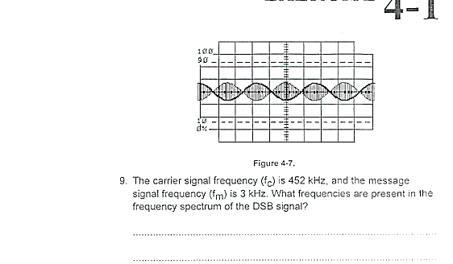

## Procedure B: LSB Filter

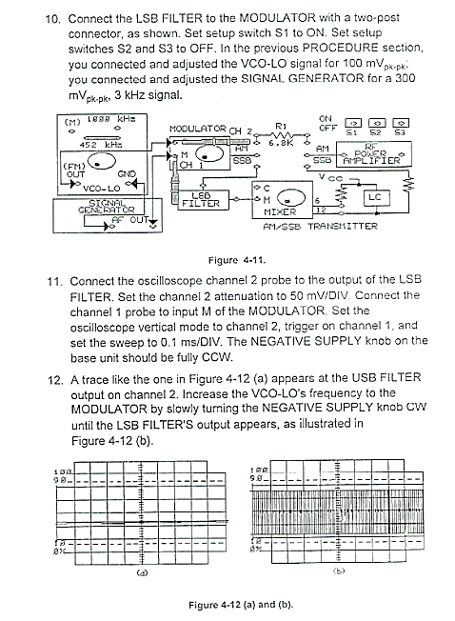

## Deliverables

* **Step 8**

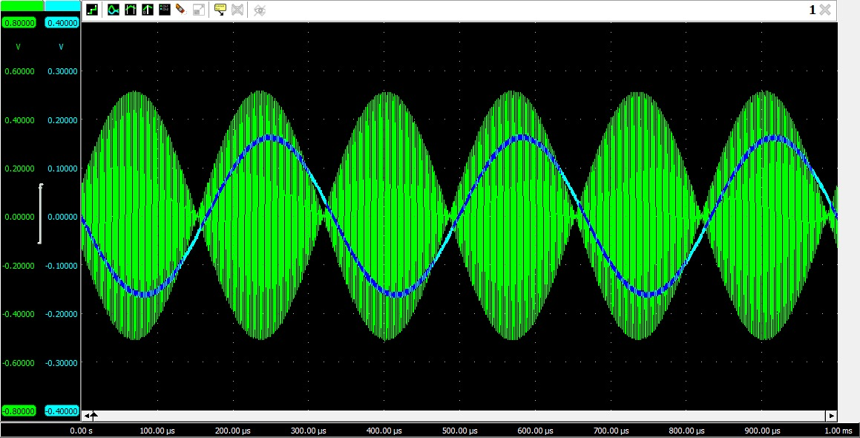

Figure : DSB Signal

* **Step 9**

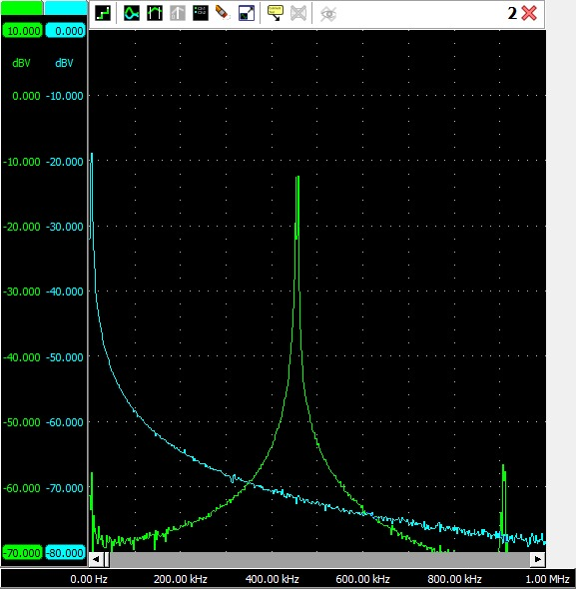

Figure : FFT Spectrum

* **Step 12**

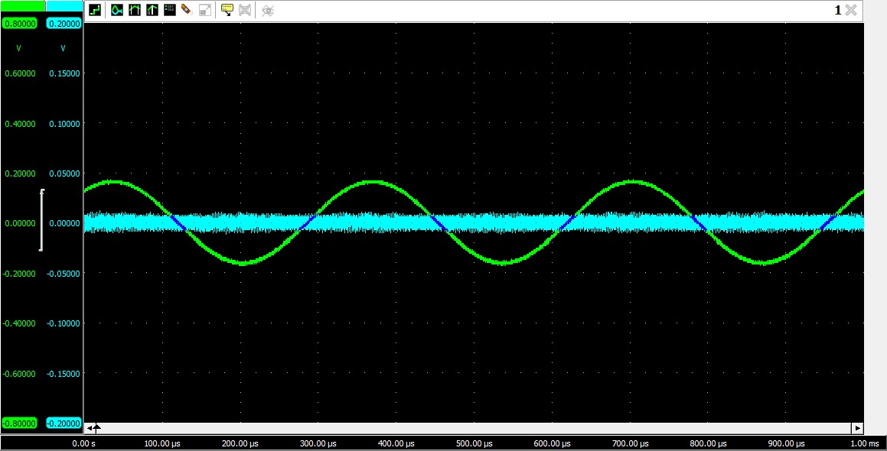

Figure : Filtered Output

* **Step 15**

Yes, the amplitude of the 455 kHz signal varies with the amplitude of the message signal.

* **Step 17**

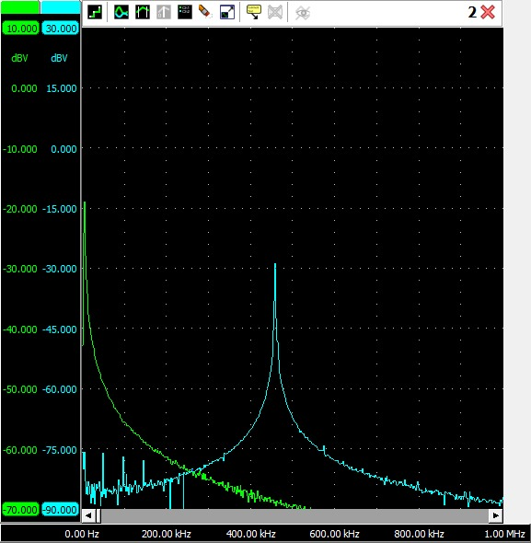

The obtained spectrum possesses the type A attenuation characteristics.

* **Step 18**

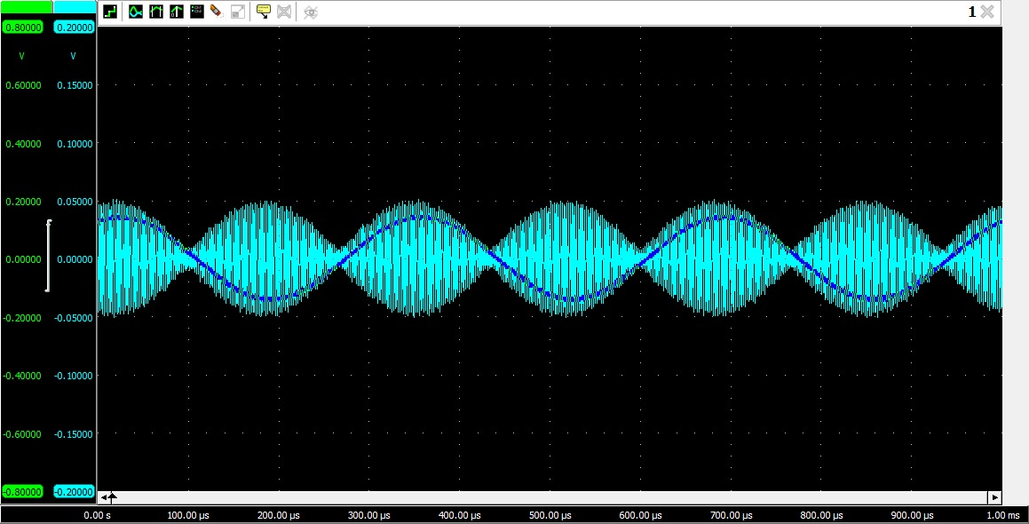

Figure : 100% Modulation

* **Step 19**

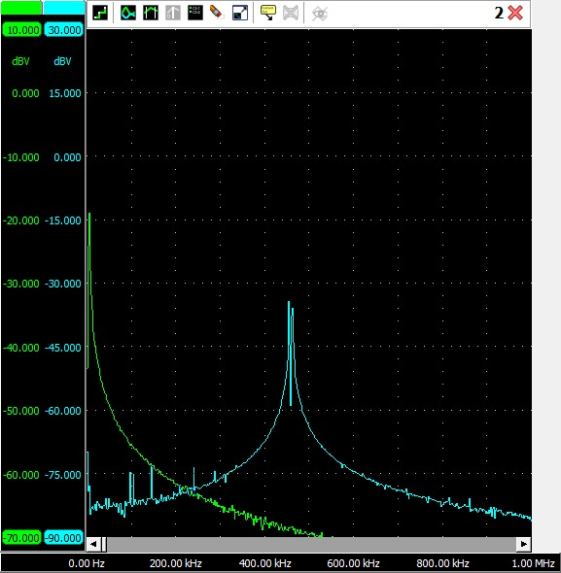

Figure : FFT Spectrum

* **Step 21**

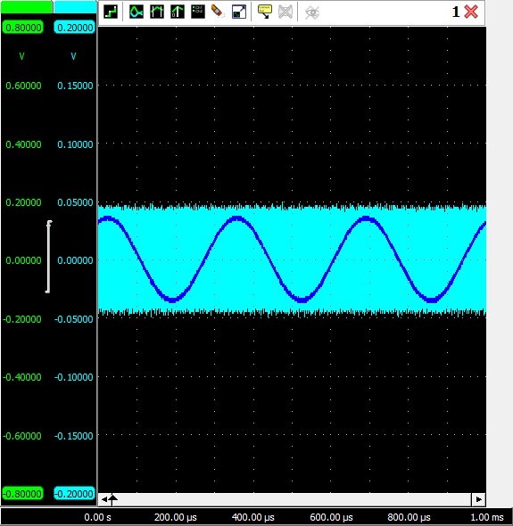

Figure : CW NEG Supply Output

* **Step 22**

The obtained spectrum possesses the type B attenuation characteristics

# Exercise 2: Mixer and RF Amplifier

## Introduction

## Procedure A: Adjust the Circuit for a 455 kHz to the MIXER

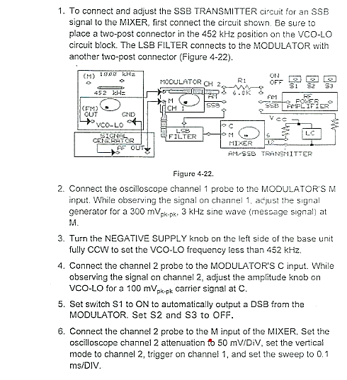

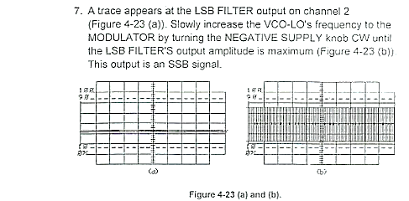

## Procedure B: Convert the 455 kHz SSB to a 1000 kHz SSB

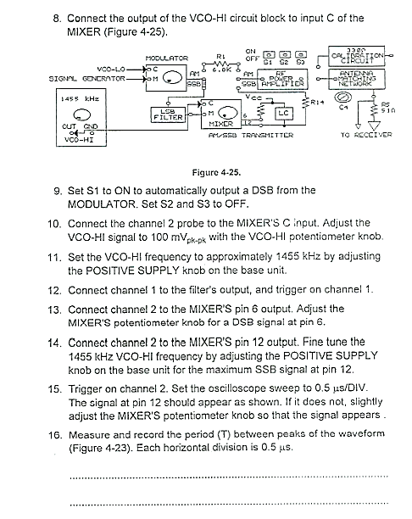

## Procedure C: RF Power Amplifier and Antenna Matching Network

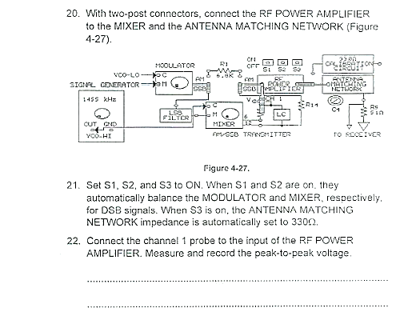

## Deliverables

* **Step 7**

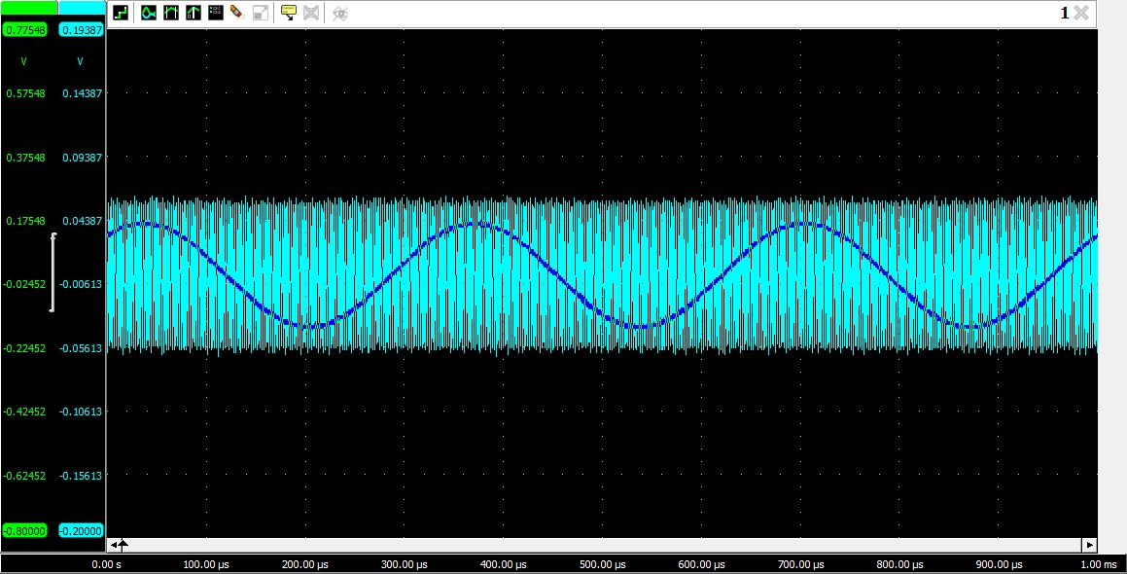

Figure : LSB Filter Output Trace

* **Step 13**

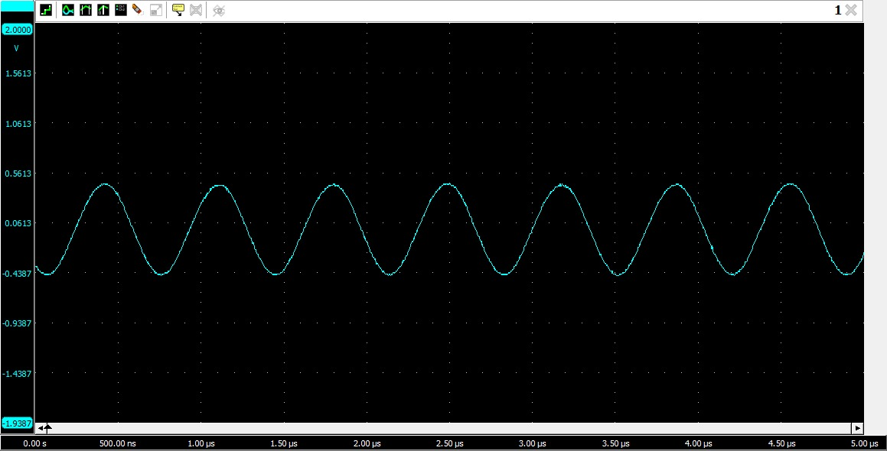

Figure : DSB Signal

* **Step 16**

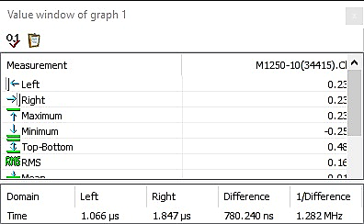

Figure : Period T Calculation

T

* **Step 17**

f =

* **Step 18**

No, the amplitude of the 1000 kHz signal does not vary with the amplitude of the message signal.

* **Step 22**

Vp-p =

* **Step 23**

Pi =

* **Step 24**

Vo =

* **Step 25**

Po =

* **Step 26**

Ap =

* **Step 27**

Pt =

* **Step 28**

BW =

# Conclusion

In conclusion, the use of a balanced modulator to generate DSB signals and the extraction of SSB signals from them using a LSB filter have been discussed in this report. SSB signals offer several advantages over DSB signals, such as low power consumption and narrow bandwidth. The practical applications of these modulation techniques are widespread, and they are commonly used in radio communication and signal processing.